مواصفات أنشطة علاجية المجمع الطبي
طلبية رقم 129

# | اسم الصنف | ملاحظات | صورة توضيحية
1 | Abdominal straps | Strong, durable hook-and-loop closure for secure positioning  Padded, soft surface  Sized to fit most tilt tables | 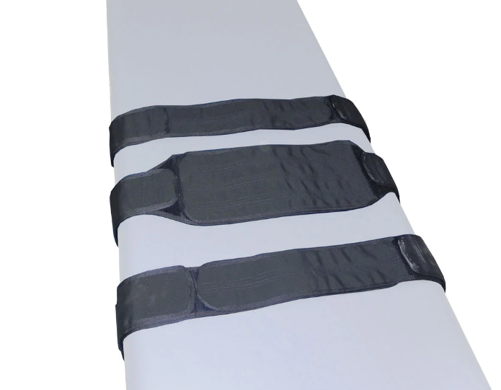
2 | Norco MiniVibrator MultiHead MassagerNorco MiniVibrator Mult | Mini Massager tool  Length 5" (13cm)  Weight 5 .5 oz.  Vibration Speed 92 cycles per second  Amplitude 0.06 mm  Warranty 90 days | 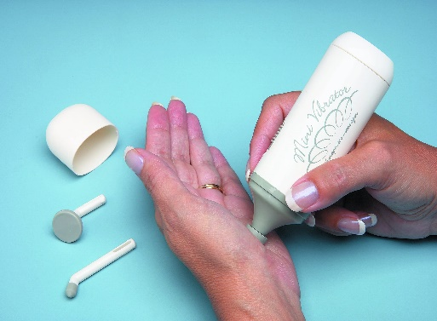
3 | PT Assessment | Physical Therapy kit is pre-packaged with the items includes 4 for each of them:  Baseline Absolute + Axis attachment, Hydraulic goniometer.  24-hour electronic stopwatch/watch combination  Baseline 12" 360° clear plastic goniometer  Baseline 6" 180° clear plastic goniometer  Taylor hammer  Baseline pocket aneroid sphygmomanometer  Dual-headed stethoscope  Baseline woven measurement tape  Gait belt with a metal buckle | 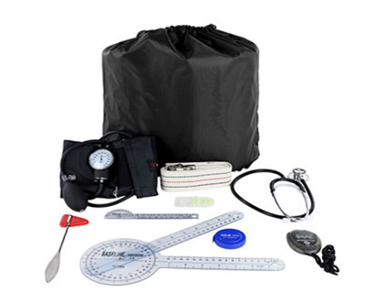
4 | Rolyan Horizontal ring tree | Horizontal ring tree | 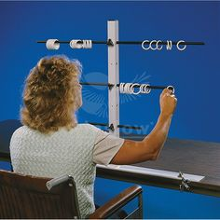
5 | Fitness First Soft Wall Ball, 5-25 LBS, Durable Reinforced | NEW design for optimal durability - reinforced stitching and improved materials  Heavy duty, triple stitched soft shell covering  Special construction allows ball to maintain balance and keep shape  Not to be used as a slam ball  Diameter - 22 inches | 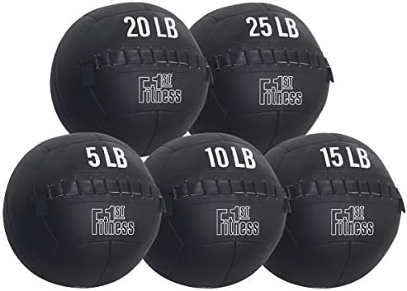
6 | PVC SEMICIRCUELR BALL | A diameter of about 16 cm, a height of around 8-10 cm, and a weight of approximately 260-285 grams. The material is PVC, available in various colors, and they are often used for massage, balance, and yoga exercises | 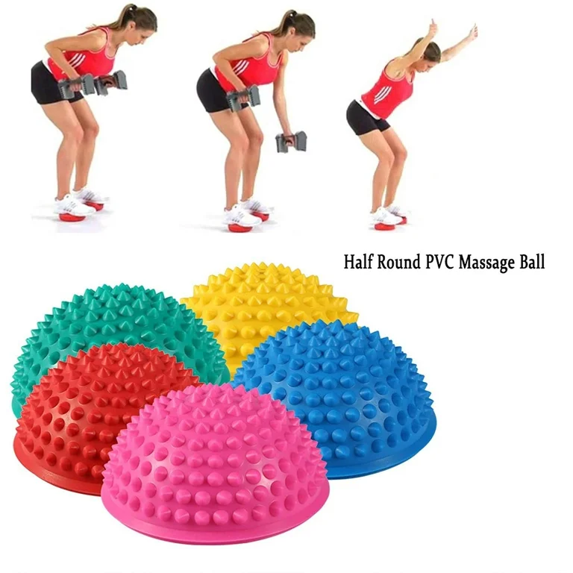
7 | Scar pump | Suction pump designed to aid in scar massage and healing by creating negative pressure to draw skin away from tissue adhesions. Key specifications include a non-latex construction, a suctioning nozzle, and four different sizes of suction cups | 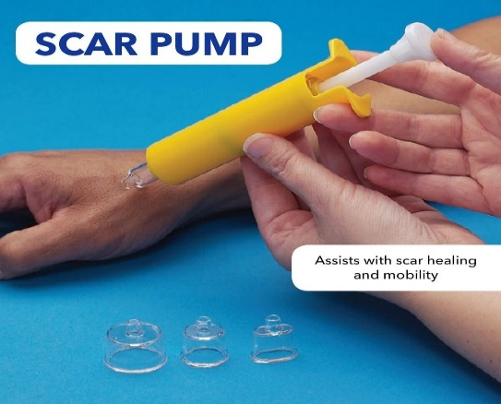
8 | Traffic cones | Soccer Cones, Cones Sports Training Agility Field Marker Plastic Traffic Cones | 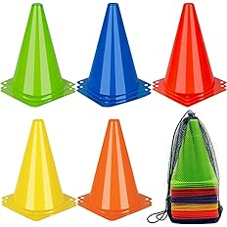
9 | Paraffin Wax | A soft, white, odorless wax used in therapeutic treatments for conditions like arthritis and dry skin. It is melted and applied to the skin to provide heat therapy and moisturization
10 | Rolyan vertical ring tree | Hand Therapy Exercises | Hand Grips | Finger Exercises | Hand Exercises | Rehabilitation | 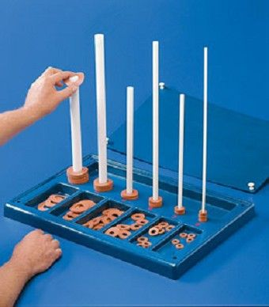
11 | Flex Therapy Bar | Flex Therapy Bar,Tennis Elbow Therapy Bar, Flexbar for Physical Therapy & Resistance Bar for Golfers Elbow,Tendinitis,Wrist,Forearms Pain, Improve Grip Strength and Relieve Pain | 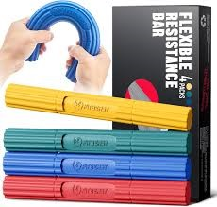
12 | Elastic threading exercise for occupational therapist | Elastic exercise for occupational therapist | 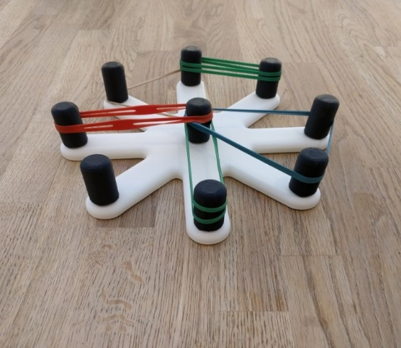
13 | Sensory stress ball for kids and adults | A soft, squeezable ball designed to provide tactile stimulation and relieve stress. Ideal for both children and adults, it helps improve focus, reduce anxiety, and promote hand strength. Available in various textures and colors to engage different sensory preferences | 